“Early reading, whether it is in a parent’s lap, on the carpet of a classroom, or in a snug reading corner, gently but indelibly imprints upon us the mould from which will cast a lifetime of communication in the world. “
Alex Quigley – Closing the Reading Gap 2020.

Welcome to the Caldecote Reading Spine. This is our fiction spine. In time, we will be adding non-fiction and poetry.
It is important to stress that the recommended books for each year group are ideas to help guide the children towards age appropriate books. We have included three levels of books dependent on your child’s reading skills. We have considered many aspects when compiling this list:
- There is a picture book (In red bold) included in each year group. As your child becomes a more competent reader their decoding and fluency skills improve. Sometimes, in KS2, picture books can be judged as an ‘easy read’ however these books often carry complex themes which help develop children’s inference and prediction skills. They are invaluable for discussion both within and out of the classroom setting.
- Research has consistently shown that there is a gender gap in reading attainment with girls outperforming boys. Our list ensures that there are books that will encourage and enthuse both genders.
- We have included ‘aspirational’ reads. Books that are challenging including language and themes.
- We have used some titles recommended by educational experts such as Pie Corbett, The National Literacy Trust, and prestigious children’s book award nominations.
- Links to our ‘cultural capital’ – exposing our children to different cultures and childhood experiences.
- A reading rich school embraces all our community. We need to work together to inspire our children to engage in the love of reading. We have included a ‘staff choice’ page. These books are the ones that we enjoyed reading as children or adults, where we lost ourselves in imaginary worlds with leading heroes and heroines.

EYFS

EYFS and Y1 are pivotal year groups for developing the skill of reading and emerging children in the wonder of stories. The teaching staff align all the different reading experiences every child has when they join our school. Some children will have daily exposure to stories while others, little introduction to the world of children’s literature. At Caldecote, we have chosen some key picture books that will help lay the foundation for engagement and enjoyment towards reading. For the class books, the teachers have chosen one of many books that they use to enrich the EYFS and Y1 curriculum.
EYFS Reading Spine
Class Books
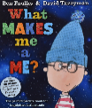  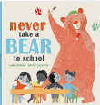  Autumn 1 – All About Me  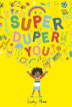  Never Take a Bear to School – Mark Sperring  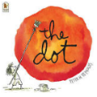  Super Duper You – Sophie Henn  The Dot – Peter Reynolds  What Makes Me Me – Ben Faulks | 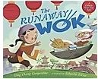  Autumn 2 – Festivals & Celebrations  The Runaway Wok – Ying Chang Compestine & Sebestia Serra  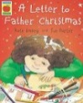  Alfie's Christmas - Shirley Hughes  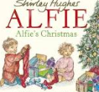  A Letter to Father Christmas –  Rose Impey
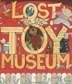  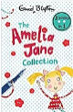  Spring 1 – Switch It On Toys  The Amelia Jane Collection – Enid Blyton  Lost in the Toy Museum - David Lucas | 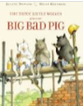  Spring 2 -Will You Read Me A Story? Traditional Tales  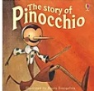  The Story of Pinnocchio –  Katie Daynes  The 3 Wolves and the Big Bad Pig - Eugene Trivizas
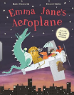  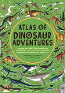  Summer 1 – Where Do They Live?  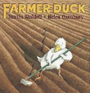  Atlas of Dinosaur Adventures – Emily Hawkins  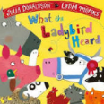  Emma Jane’s Aeroplane –  Katie Haworth  What the Ladybird Heard –  Julia Donaldson  Farmer Duck - Martin Waddell | Summer 2 – Are We There Yet?  Mrs Armitage on Wheels – Quentin Blake  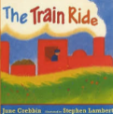  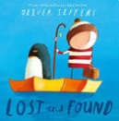  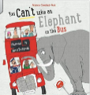  You Can’t Take an Elephant on a Bus – Patricia Cleveland Peck  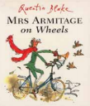  Lost and Found - Oliver Jeffers  The Train Ride - June Crebbin
EYFS Reading Spine
Children’s recommended Book List
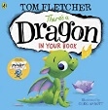  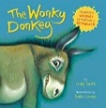  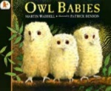  Owl Babies –  Martin Waddell  Wonky Donkey – Craig Smith  There’s a Dragon in your Book – Tom Fletcher | 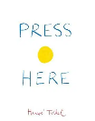  Press Here –  Herve Tullet  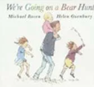  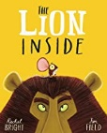  The Lion Inside – Rachel Bright  We’re Going on a Bear Hunt – Michael Rosen
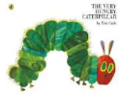  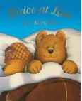  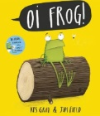  Oi Frog! Kes Grey and Jim Field  Peace at Last –  Jill Murphy  The Very Hungry Caterpillar – Eric Carle | 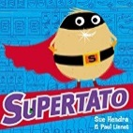  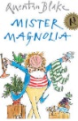  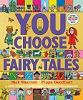  Mr Magnolia –  Quentin Blake  Supertato – Sue Hendra  You Choose Fairy Tales – Nick Sharrot & Pippa Goodheart
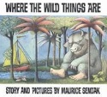  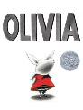  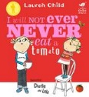  Where the Wild Things Are – Maurice Sendak  Olivia – Ian Falconer  I Will Not Ever Eat a Tomato – Lauren Child | 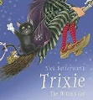  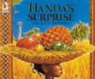  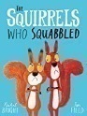  The Squirrels who Squabbled – Rachel Bright & Jim Field  Handa’s Surprise – Eileen Browne  Trixie the Cat – Nick Butterworth

Year 1
Year 1 Reading Spine
Class Books
Autumn 1 – Space  Beegu – Alex Deacon  Alien Tea on Planet Zum Zee – Tony Mitton  Aliens Love Underpants Save the World - Claire Freedman  Bob, Man on the Moon – Simon Bartram  The Way Back Home – Oliver Jeffers  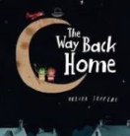  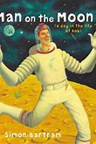  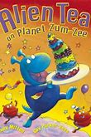  How to catch a star – Oliver Jeffers  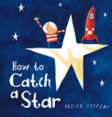  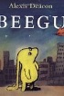  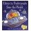 | Autumn 2 – Muck, Mess and Mixtures  George’s Marvellous Medicine – Roald Dahl  Revolting Recipes – Roald Dahl  Mr Messy - Roger Hargreaves  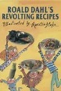  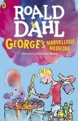  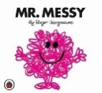
Spring 1 – Land Ahoy! Pirates  The Night Pirates – Peter Harris  The Lighthouse Keeper’s Lunch – Richard Armitage  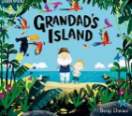  The Little Mermaid – Hans Christian Anderson  The Spell Shell – Roderick Hunt  Wave – Suzy Lee  Grandad’s Island – Benji Davies  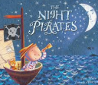  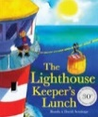  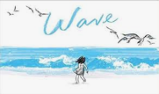  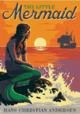  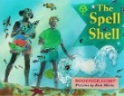 | Spring 2 – Paws, Claws & Whiskers  Dear Zoo – Rod Campbell  Bringing the Rain to Kapiti Plain – Verna Aardema  Lila and the Secret of Rain – David Conway  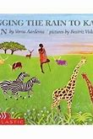  Masai and I – Virginia Kroll  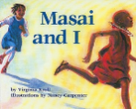  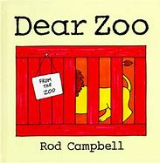  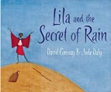
Summer 1 – Enchanted Woodland  Peter Rabbit – Beatrix Potter  Wild – Emily Hughes  The Minpins – Roald Dahl  Tree – Britta Teckentrup  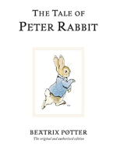  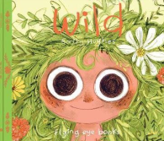  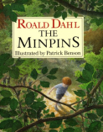  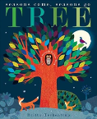 | Summer 2 – Towers, Turrets & Tunnels  Rapunzel – Brothers Grimm Traditional  George and the Dragon – Christopher Wormell  Zog – Julia Donaldson  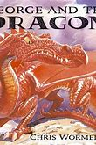  The Story Book Knight – Helen Docherty  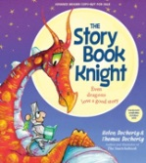  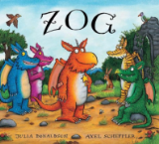  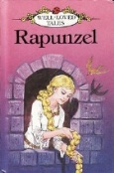
Year 1 Reading Spine
Children’s recommended Book List
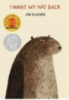  Blue Balloon –  Mick Inkpen  Aliens Love Underpants Claire Freedman  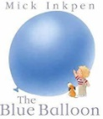  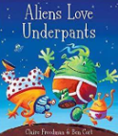  I Want my Hat Back –  Jan Klassen | 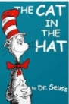  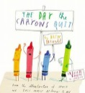  The Cat in the Hat –  Dr Seuss  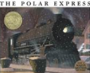  The Polar Express –  Chris Van Allsberg  The Day the Crayons Quit  Oliver Jeffers
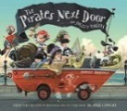  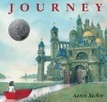  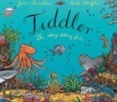  The Pirates Next Door – Jonny Duddle  Journey –  Aaron Becker  Tiddler – Julia Donaldson | 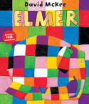  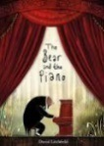  Elmer – David McKee  The Bear and the Piano – David Litchfield
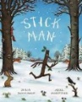  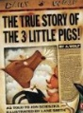  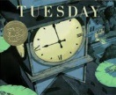  Stick Man – Julia Donaldson  The True Story of the Three Little Pigs – Jon Scieszka  Tuesday – David Weisner | 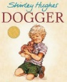  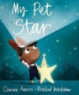  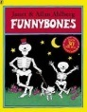  Funnybones - Allan Ahlberg  My Pet Star – Corinne Averiss & Rosalind Beardshaw  Dogger – Shirley Hughes
Year 2
Year 2 is a transition year where children are going from emergent readers learning to decode and to acquiring more skills such as fluency and accuracy. The books included are to illustrate the range of reading skills our Y2 children have but also to challenge them, exposing them to new words and themes. The fiction books have been chosen to inspire, engage and enthuse our children on their literature journey through our primary school. It is imperative that children share the wonders of illustrations and key themes often included in picture books.
Year 2 Reading Spine
Class Books & Novels
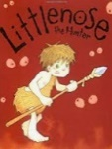  Autumn 1 – Dinosaurs  Little Nose – John Grant | 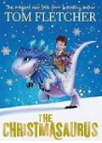  Autumn 2 – Rio de Vida  The Christmasaurus – Tom Fletcher
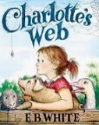  Spring 1 – Wriggle and Crawl  Charlotte’s Web – EB White | 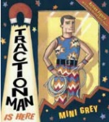  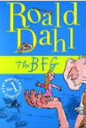  Spring 2 – Super Heroes  Traction Man – Mini Grey  The BFG – Roald Dahl
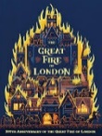  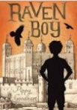  Summer 1 – Bright Lights  Raven Boy – Pippa Goodhart  The Great Fire of London – Emma Adams | 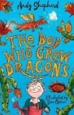  Summer 2 – Street Detectives  The Boy who Grew Dragons –  Andy Shepherd.
Year 2 Reading Spine
Children’s recommended Book List
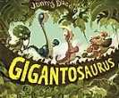  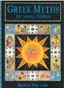  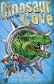  Gigantosaurus – Jonny Duddle  Greek Myths – Marcia Williams  Dinosaur Cove series – Mixture of authors | 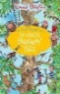  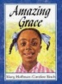  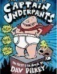  Amazing Grace – Mary Hoffman & Caroline Binch  Captain Underpants – Dav Pilkey  The Magic Faraway Tree – Enid Blyton
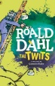  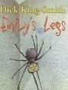  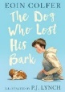  The Twits – Roald Dahl  Emily’s legs – Dick King Smith  The Dog who Lost his Bark- Eoin Colfer | 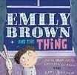  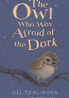  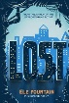  Emily Brown and the Thing – Cressida Cowell  The Owl who was afraid of the Dark – Jill Murphy  Lost – Eli Fountain
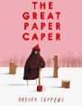  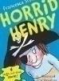  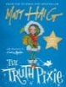  The Great Paper Caper –  Oliver Jeffers  Horrid Henry – Francesca Simon  The Truth Pixie – Matt Haig | 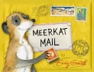  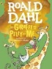  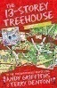  Meerkat Mail – Emily Gravett  The Giraffe and the Pelly and Me – Roald Dahl  The 13 Storey Tree House – Andy Griffiths & Terry Denton

Year 3

Year 3 Reading Spine
Class Novels
Autumn 1 – Tribal Tales  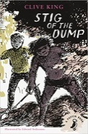  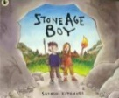  Stone Age Boy –  Satoshi Kitamura  Stig of the Dump – Clive King | 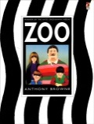  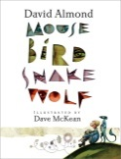  Autumn 2 – Predator  Mouse Bird Snake Wolf –  David Almond  Zoo – Anthony Browne
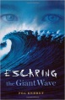  Spring 1 – Weather and Climate  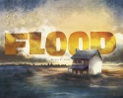  Flood – Alvaro F. Villa  Escaping the Giant Wave –  Peg Kehret | 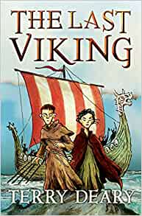  Spring 2 – Traders and Raiders  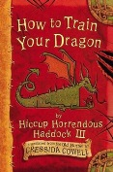  The Last Viking – Terry Deary  How to Train a Dragon – Cressida Cowell
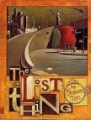  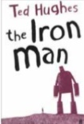  Summer 1 – Mighty Metals  The Iron Man – Ted Hughes  The Lost Thing – Shaun Tan | 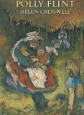  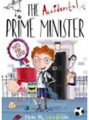  Summer 2 – Towns and Cities  The Accidental prime Minister – Tom Mclaughlin  The Secret World of Polly Flint – Helen Cresswell
Year 3 Reading Spine
Children’s recommended Book List
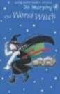  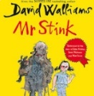  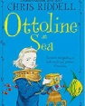  The Worst Witch –  Jill Murphy  Mr Stink –  David Walliams  Ottoline – Chris Riddel | 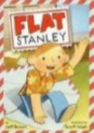  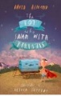  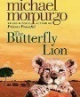  Flat Stanley – Geff Brown  The Boy Who Swam with Piranhas – David Almond  The Butterfly Lion – Michael Morpurgo
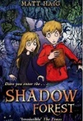  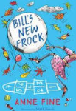  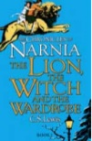  Bill’s New Frock –  Anne Fine  Shadow Forest –  Matt Haig  The Lion, The Witch and The Wardrobe – CS Lewis | The Hundred Hour Dog –  Jeremy Strong  Kid Normal – Greg James & Chris Smith  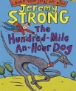  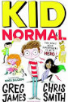
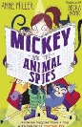  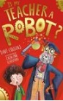  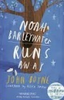  Mickey & the Animal Spies – Anne Miller  Is My Teacher a Robot – Dave Cousins  Noah Barleywater Runs Away – John Boyne | Planet Omar Unexpected Super Spy – Zanib Mian  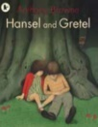  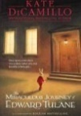  Hansel and Gretel –  Anthony Browne  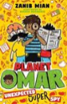  The Miraculous Journey of Edward Tulane – Kate DiCamillo

Year 4
Year 4 Reading Spine
Class Novels
Autumn 1 – Potions  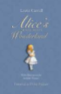  Alice’s Adventures in Wonderland –  Lewis Carroll | 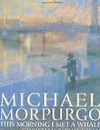  Autumn 2 – Flow  The Morning I Met a Whale –  Michael Morpurgo
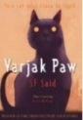  Spring 1 – I am Warrior  Varjak Paw – SF Said | 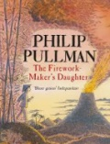  Spring 2 - Tremors  The Firework Maker’s Daughter-  Philip Pullman
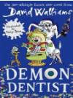  Summer 1 – Burbs, Bottoms and Bile  Demon Dentist – David Walliams | 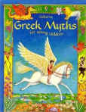  Summer 2 – Gods and Mortals  Greek Myths for Young Children –  Heather Amery
Year 4 Reading Spine
Children’s recommended Book List
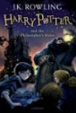  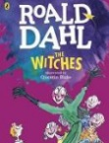  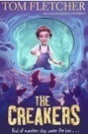  The Creakers – Tom Fletcher  The Witches – Roald Dahl  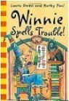  Harry Potter and the Philosopher’s Stone – JK Rowling  Winnie Spells Trouble – Laura Owens | 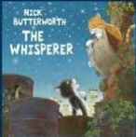  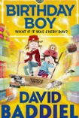  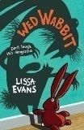  The Whisperer – Nick Butterworth  Birthday Boy –  David Baddiel  Wed Wabbit – Lissa Evans
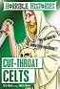  The Chicken Gave it to Me – Anne Fine  Series of Unfortunate Events – Lemony Snicket  Rotten Romans  Cut Throat Celts  Terry Deary  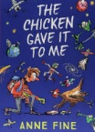  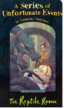 | 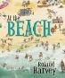  At the Beach – Roland Harvey  When the Mountains Roared – Jess Butterworth  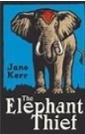  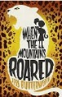  The Elephant Thief –  Jane Kerr
The Akimbo Adventures –  Alexander McCall Smith  The Legend of Podkin One Ear – Kieran Larwood  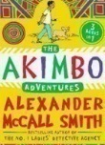  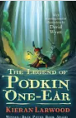 | 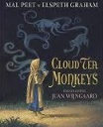  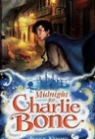  Cloud Tea Monkeys – Mal Peet & Elsbeth Graham  Midnight for Charlie Bone –  Jenny Nimmo

Year 5 Reading Spine
Class Novels
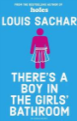  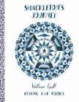  Autumn 1 – Frozen Kingdom  Shackleton’s Journey – William Grill  There’s a Boy in the Girl’s Bathroom – Louis Sacher | 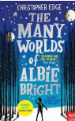  Autumn 2 – Stargazer  The Many Worlds of Albie Bright – Christopher Edge
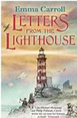  Spring 1 – A Child’s War  Letters from the Lighthouse – Emma Carroll | Spring 2 – Allotment  Letters from the Lighthouse Cont. – Emma Carroll
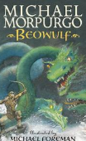  Summer 1 – Anglo Saxons and Scots  Versions of Beowulf | 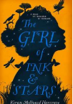  Summer 2 – Beast Creator  The Girl of Ink and Stars – Kiaran Millwod
Year 5 Reading Spine
Children’s recommended Book List
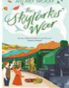  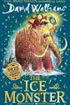  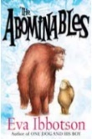  Ice Age Monster-  David Walliams  The Abomnables –  Eva Ibbotson  Skylark’s War –  Hilary McKay | 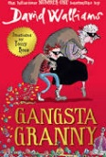  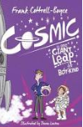  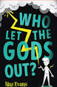  Gangsta Granny –  David Walliams  Who Let the Gods Out – Maz Evans  Cosmic –  Frank Cottrell-Boyce
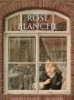  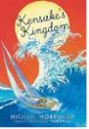  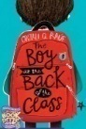  Rose Blanche – Ian McEwen  The Boy at the Back of the Class – Onjali Q Rauf  Kensuke’s Kingdom – Michael Morpurgo | 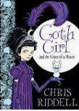  Goth Girl – Chris Riddel  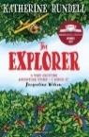  The Explorer –  Katherine Rundell
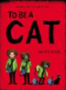  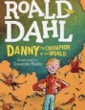  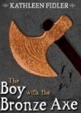  To Be A Cat – Matt Haig  Danny the Champion of the World – Roald Dahl  The Bronze Axe – Katherine Fidler | 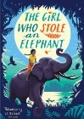  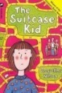  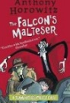  The Falcon’s Malteser – Anthony Horiwitz  Suitcase Kid – Jacqueline Wilson  The Girl Who Stole an Elephant – Nazrana Farook
Year 5

Year 6

Year 6 Reading Spine
Class Novels
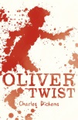  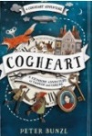  Autumn 1 – Industrial Revolution  Oliver Twist – Charles Dickens  Cogheart – Peter Bunzl | 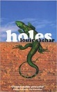  Autumn 2 – Hola Mexico & the Mayans  Holes - Louis Sachar
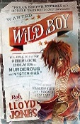  Spring 1 – ID and Blood Heart  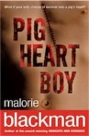  Pig Heart Boy – Malorie Blackman  Wild Boy – Rob Llyod Jones | 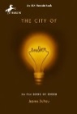  Spring 2 – Biomes and Globalisation  The City of Ember – Jeanne DuPrau
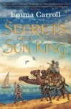  Summer 1 – Revolutions  Secrets of a Sun King – Emma Carroll | 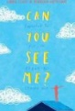  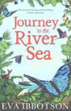  Summer 2 – Darwin’s Delights  Journey to the River Sea – Eva Ibbotson  Can You See Me? - Libby Scott& Rebecca Westcott
Year 6 Reading Spine
Children’s recommended Book List
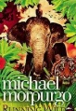  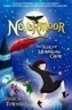  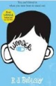  Running Wild –  Michael Morpurgo  Nevermore –  Jessica Townsend  Wonder – RJ Palacio | 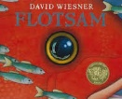  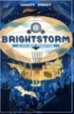  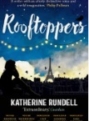  Flotsam – David Weisner  Brightstorm -  Vashti Hardy  Rooftoppers –  Katherine Rundell
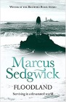  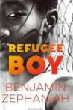  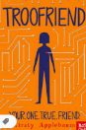  Troofriend –  Kirsty Applebaum  Refugee Boy – Benjamin Zephaniah  Floodland – Marcus Sedgwick | The Arrival – Shaun Tan  Northern Lights –  Philip Pullman  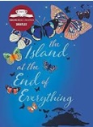  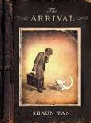  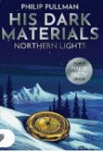  The Island at the End of Everything – Kiran Millwood Hargrave
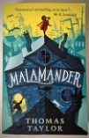  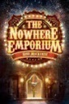  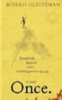  Malamander – Thomas Taylor  The Nowhere Emporium –  Ross MacKenzie  Once – Morris Gleitzman | 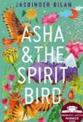  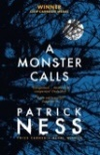  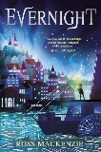  A Monster Calls– Patrick Ness  Asha and the Spirit Bird - Jasbinder Bila  Evernight – Ross Mackenzie

